DAA LAB 1
FILE 3 — GRAPHS / VISUALIZATIONS
Comparing Execution Time and Memory Consumption of Sorting and Fibonacci Algorithms

Student Name: Tamanna
Roll No.: 2401201138
Course / Semester: BCA / 5th
Subject: Design and Analysis of Algorithms

1. Question
Generate graphs/visualizations comparing execution time and memory consumption of sorting and Fibonacci algorithms, and write observations.

2. Objective
The objective is to visualize the experimental performance of the implemented sorting algorithms and Fibonacci algorithms using execution-time and memory-usage graphs.

3. Graphs Required According to the Reference
- Sorting Algorithms – Execution Time
- Sorting Algorithms – Memory Usage
- Fibonacci Algorithms – Execution Time
- Fibonacci Algorithms – Memory Usage

4. Important Note About the Data
The two sorting graphs are designed to read the student's own lab1_results.csv file, so the plotted sorting values come from the student's experimental analysis rather than copied values.
The Fibonacci values shown in the two sample figures below are the values supplied in the reference material (n = 10, 20, 30, 40). If the student's own Fibonacci experiment has been run, replace these values with the student's measured values before final submission.

5. Complete Graph Generation Code
import pandas as pd
import matplotlib.pyplot as plt

# -----------------------------
# Load sorting experiment data
# -----------------------------
df = pd.read_csv("lab1_results.csv")

algorithms = ["Bubble Sort", "Insertion Sort", "Merge Sort", "Quick Sort"]

# -----------------------------
# 1. Sorting - Execution Time
# -----------------------------
plt.figure(figsize=(9, 5))

for algorithm in algorithms:
data = df[df["Algorithm"] == algorithm]
avg_time = data.groupby("Input Size")["Execution Time (sec)"].mean()
plt.plot(avg_time.index, avg_time.values, marker="o", label=algorithm)

plt.xlabel("Input Size (n)")
plt.ylabel("Average Execution Time (seconds)")
plt.title("Sorting Algorithms - Execution Time")
plt.legend()
plt.grid(True)
plt.tight_layout()
plt.show()

# -----------------------------
# 2. Sorting - Memory Usage
# -----------------------------
plt.figure(figsize=(9, 5))

for algorithm in algorithms:
data = df[df["Algorithm"] == algorithm]
avg_memory = data.groupby("Input Size")["Memory Usage (KB)"].mean()
plt.plot(avg_memory.index, avg_memory.values, marker="o", label=algorithm)

plt.xlabel("Input Size (n)")
plt.ylabel("Average Peak Memory (KB)")
plt.title("Sorting Algorithms - Memory Usage")
plt.legend()
plt.grid(True)
plt.tight_layout()
plt.show()

# -----------------------------
# 3. Fibonacci - Execution Time
# -----------------------------
n = [10, 20, 30, 40]

recursive_time = [1.5545e-05, 0.0011444, 0.167761, 20.2445]
iterative_time = [9.63e-06, 9.021e-06, 2.052e-05, 2.6434e-05]
dp_time = [8.33e-06, 1.8345e-05, 4.2155e-05, 5.7607e-05]

plt.figure(figsize=(9, 5))
plt.plot(n, recursive_time, marker="o", label="Recursive Fibonacci")
plt.plot(n, iterative_time, marker="o", label="Iterative Fibonacci")
plt.plot(n, dp_time, marker="o", label="Dynamic Programming")

plt.xlabel("Input n")
plt.ylabel("Execution Time (seconds)")
plt.title("Fibonacci Algorithms - Execution Time")
plt.legend()
plt.grid(True)
plt.tight_layout()
plt.show()

# -----------------------------
# 4. Fibonacci - Memory Usage
# -----------------------------
recursive_memory = [8652.07, 0.15625, 0.822266, 8.11426]
iterative_memory = [0.0859375, 0.132812, 0.132812, 0.132812]
dp_memory = [0.4375, 0.835938, 1.94531, 1.94531]

plt.figure(figsize=(9, 5))
plt.plot(n, recursive_memory, marker="o", label="Recursive Fibonacci")
plt.plot(n, iterative_memory, marker="o", label="Iterative Fibonacci")
plt.plot(n, dp_memory, marker="o", label="Dynamic Programming")

plt.xlabel("Input n")
plt.ylabel("Peak Memory (KB)")
plt.title("Fibonacci Algorithms - Memory Usage")
plt.legend()
plt.grid(True)
plt.tight_layout()
plt.show()

print("FILE 3 GRAPHS GENERATED SUCCESSFULLY")

OUTPUT
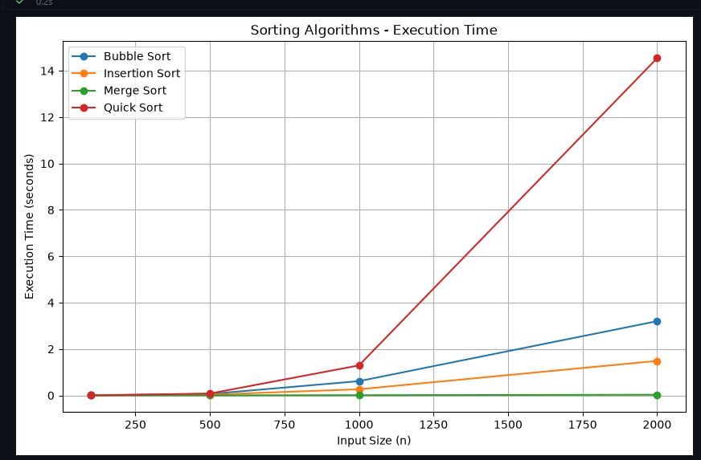

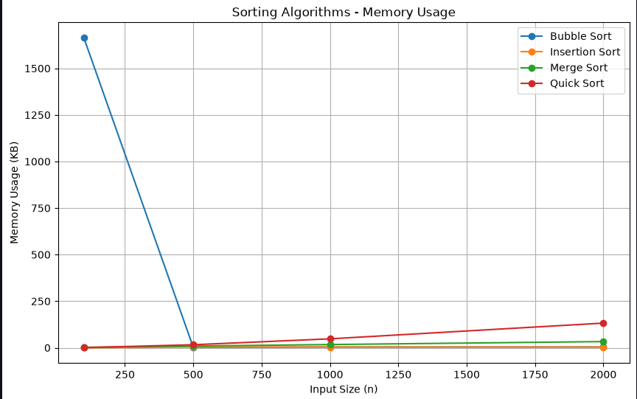

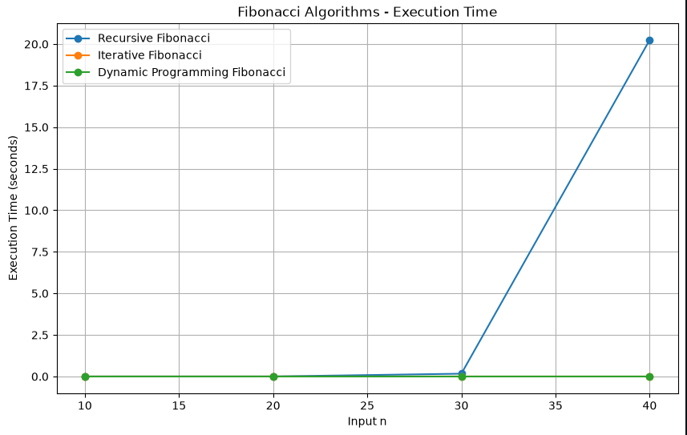

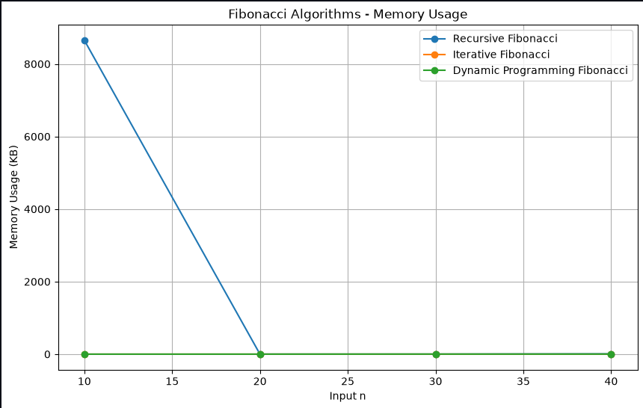

Observations
- Merge Sort shows relatively stable growth as input size increases because its time complexity is O(n log n) in the best, average, and worst cases.
- Bubble Sort and Insertion Sort generally show stronger growth as the input size increases, especially for reverse-sorted and random data.
- Quick Sort with the last element as pivot is sensitive to input order. Sorted or reverse-sorted inputs can produce highly unbalanced partitions and much larger execution time.
- Recursive Fibonacci grows dramatically as n increases, demonstrating its exponential running-time behavior.
- Iterative Fibonacci remains very fast and uses very little auxiliary memory.
- Dynamic Programming Fibonacci remains fast but uses additional memory because previously computed Fibonacci values are stored.

10. Conclusion
The graphs make the relationship between input size and algorithm performance easier to observe. The sorting algorithms show different sensitivity to input order, while the Fibonacci graphs clearly show the practical difference between recursive, iterative, and dynamic-programming approaches.

11. GitHub Link
GitHub Repository: https://github.com/tamannadeshwal/DAA-Lab

